LARS FoxHunt 9 May 2009
By Jim Russell N4ICU, a.k.a., “The Sneaky Fox”

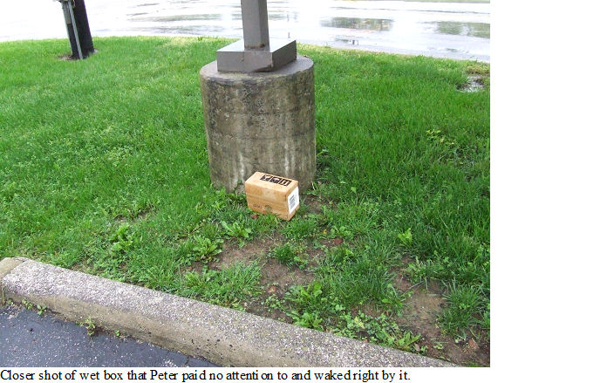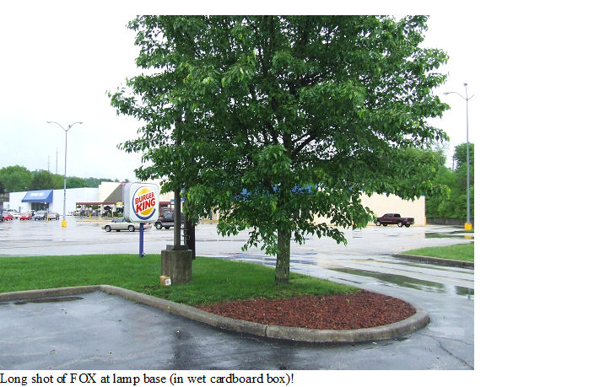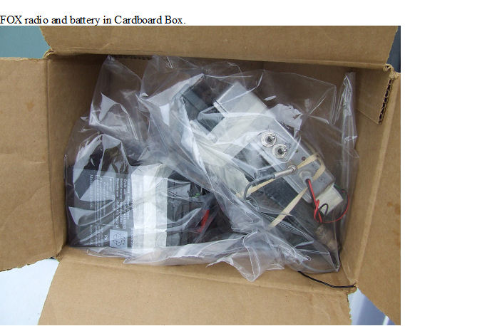

After charging some batteries and e-mailing Stanley, KD4ERF, I then went to sleep. Saturday morning I put most of the radios, camera, GPS and batteries into the car and headed to the meet Stanley & Virginia. After breakfast we went to Burger King in the north end of London. Stanley and I decided where to setup the Fox. ICU FOX was placed beside a concrete lamp base on the corner of the parking lot toward CVS. ICU FOX consisted of an ICOM IC2-AT, with the Fox controller and a gel-cell battery pack all sitting at the base of the pole in an already wet cardboard box. Then the FOX was turned on at 10:00 AM. Also,

GPS said 37° 08.403’ N
84° 06.027 W
1223 feet amsl

The 146.61 rpt was used by the hound and the following was transcribed from that. And Jim sat in Stanley’s hybrid to await the hunter!

10:00 FOX is on!
10:06 Peter, KJ4ND,announced he was mobile.
10:07 Peter said he was mobile.
10:22 Peter is getting a reading, to the North West.
10:35 Peter is getting another reading.
11:03 Peter started walking toward FOX and went right by it and came to us !!!
11:04 Peter found the ICU Fox !!!
11:05 FOX is turned off.

We found out from Peter that some of the other would be Hounds decided it was raining to hard for a fox hunt. So Peter braved the weather and was rewarded with little or no rain for the hunt !!!

Also I had forgotten to pick up my freshly charged batteries and HT’s. To listen, I had to put an extra fox battery on the other IC-2AT to be able to listen to the reports from the Hounds

We had a really good time this morning and were glad to see the hound out for the FOX.

73 & GOD Bless
Jim BJ N4ICU FOX Hard to Find Fox Treed Fox Sneaky Fox
Wet Fox

Fox Hunt of May 9, 2009
By Peter Rock KJ4ND

The day for the fox hunt day started rainy, and some of the hounds said they would not be able to make it. I was not sure if the fox hunt was on, but Stan KD4ERF, said the fox was ready to start. So the game was afoot .
The rain actually stopped just as I was leaving my QTH, so I lucked out . I headed over to the library area, and did not hear the fox on the way. I decided to climb up the hill, and at the very top using my beam, I could barely hear the fox, but not any bars on the signal mete. It was about NW. So, I plotted it on the map, and headed over to Marvin's QTH, on rt. 638. There, I barely got another reading, and it was about SW. So, I headed that direction, and turned south onto main St . The signal got much stronger, but I thought from the map that it might be over by the elementary school . But, it was weak there, and I had to turn around, and make another pass. This time, I noted the strong area better, and took some more readings, and got a reading toward the Burger King.
I headed over there, and it was off the scale. I got out on foot, and using the HT without the antenna, soon found the fox.
This was a good start to the fox hunting season, and I am looking forward to more.
73's
Peter KJ4ND

